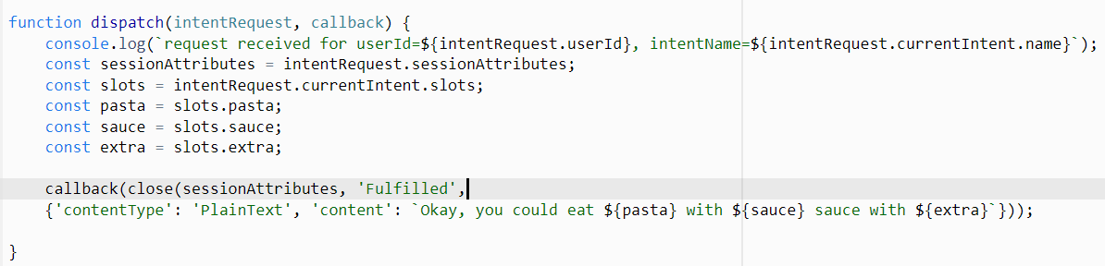

You are required to access the AWS Academy Learner Lab and utilize AWS Services such as Lambda and Amazon Lex to build your custom ChatBot and complete the Final Assignment of eMOD13 -Introduction of Cloud Computing.

You would have received a "Course Invitation" email (as sample shown) from AWS Academy and be prompted to confirm your registered email address.

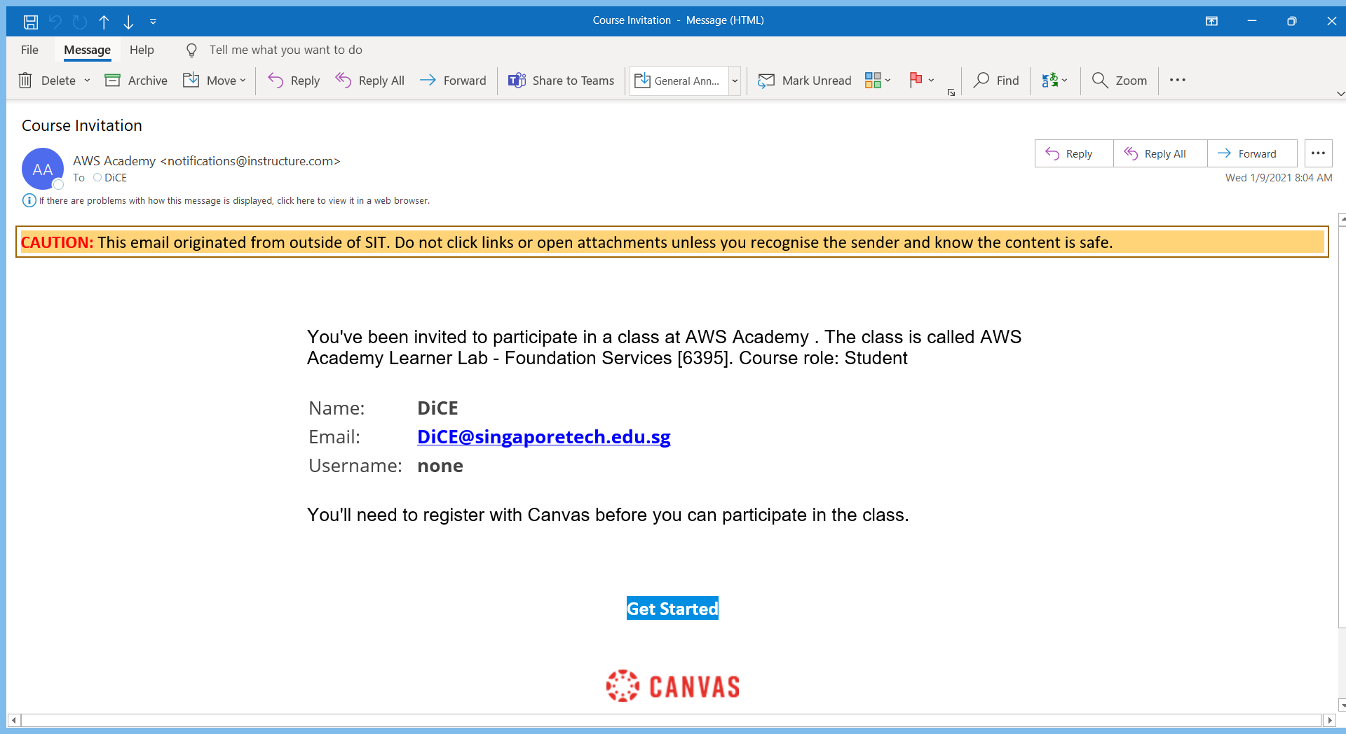

Please write to [DiCE@singaporetech.edu.sg](mailto:DiCE@singaporetech.edu.sg) to request access to the AWS Academy Learner Lab if you don't receive the "Course Invitation" email.

Do include the following details when submitting your request to access the AWS Academy Learner Lab.

* Student ID
* Name
* Programme Code
* Programme Name
* Admit Term
* SIT Email

Point to Note

* Your budget ($100) is limited so you should exercise caution to prevent charges that will deplete your budget too quickly.
* If you exceed your budget, you will lose access to your environment and lose all of your work.
* Each session lasts for 4 hours by default, although you can extend a session to run longer by pressing the start button to reset your session timer. At the end of each session, any resources you created in the account will be preserved.
* Some AWS resources, such as EC2 instances, may be automatically shut down, while other resources, such as RDS instances will be left running. Keep in mind that some AWS features cannot be stopped and can still incur charges.
* For example, an Elastic Load Balancer or a NAT. You may wish to delete those types of resources and recreate them as needed to test your work during a session. You will have access to this environment for the duration of the class you are enrolled in. When the class ends, your access to the learner lab will also end.

Activity Overview

*Prior to this Final Assignment, you are required to complete the guided development of the Pizza ChatBot in the Topic 2. With the knowledge that you have acquired, you will be required to develop another ChatBot using the same Amazon Lex and Lambda services in the same AWS Academy module. You will need to provide the screenshots of the newly developed ChatBot to answer the questions provided*

Activity Objectives

*To develop a new ChatBot, you will create another Food Menu (Burger etc.) by taking reference and modifying the codes used for the Pizza ChatBot. By doing so, you will be guided by the questions provided on the area that requires the modification.*

Learning Outcomes

By the end of this activity, you will be able to:

*Familiarize yourself with the AWS Services such as Amazon Lex and Lambda*

*Create a ChatBot from scratch*

Estimated Time

*The estimated time required to complete the whole activity is 1 hour.*

Question 1

Provide the screenshot of your **new** ChatBot Lambda Function (*In Amazon Lambda*) like the following *(X: Notice the similarities with other questions)*

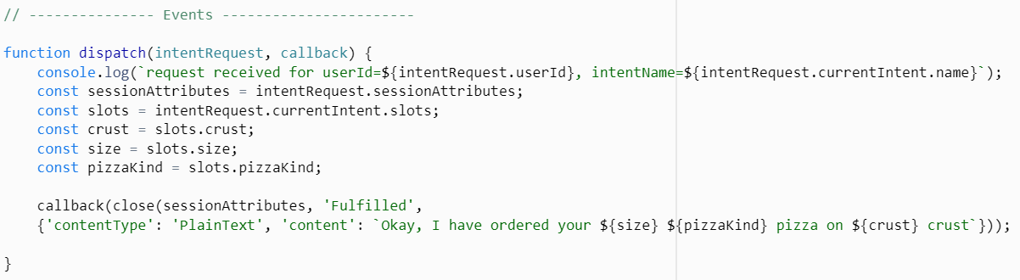

X

*Tips: Modify the area highlighted above to develop your new ChatBot to meet the requirements of the Food Menu you intend to create*

Answer



Question 2

Provide the screenshot of your **new** ChatBot Lambda “Test” Function (*In Amazon Lambda*) like the following *(X: Notice the similarities with other questions)*

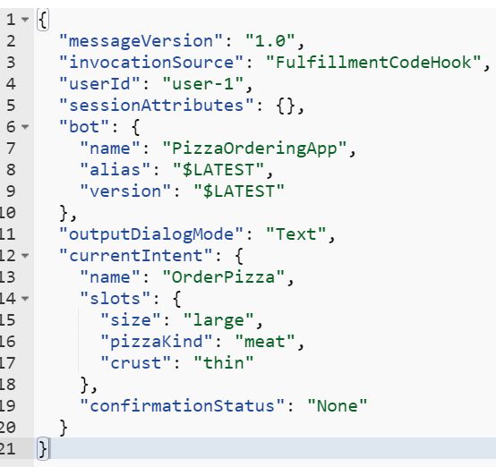

X

Intent Name

Bot Name

*Tips: Modify the area highlighted above to develop your new ChatBot to meet the requirements of the Food Menu you intend to create*

Question 3

Provide the screenshot of your **new** ChatBot “Slots” (*In Amazon Lex*) section like the following

*(X: Notice the similarities with other questions)*

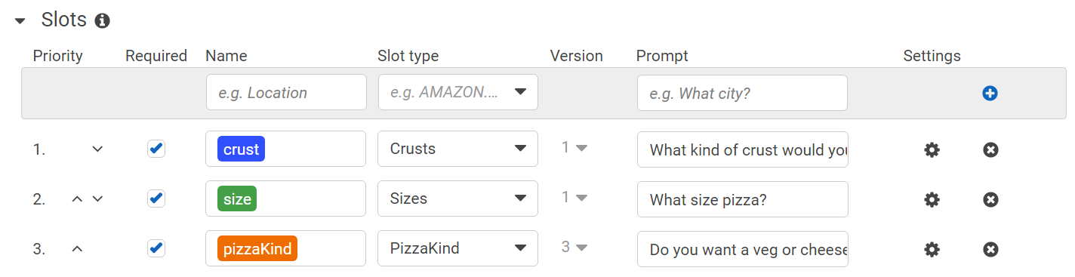

X

*Tips: Modify the area highlighted above to develop your new ChatBot to meet the requirements of the Food Menu you intend to create*

Answer

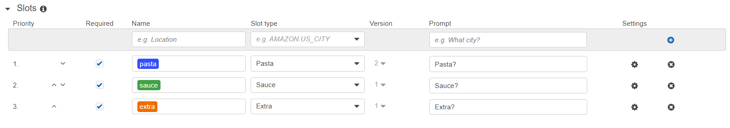

Question 4

Provide the screenshot of your **new** ChatBot – TestBot (*In Amazon Lex*) like the following. The current ***Sample Utterances***is configured as “hi”. Configure that to your name instead of using the default “hi” or “hello”.

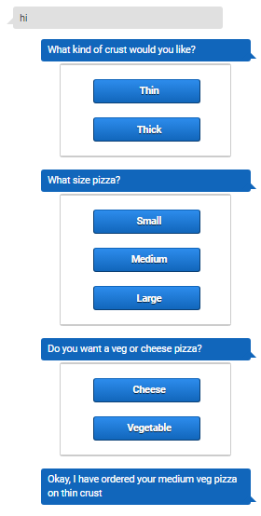

Answer

